CHOICE BOARD
Writing   Write a creative story that uses these words:  reverse, pool, puppy, celebration, deny, sunshine | Math 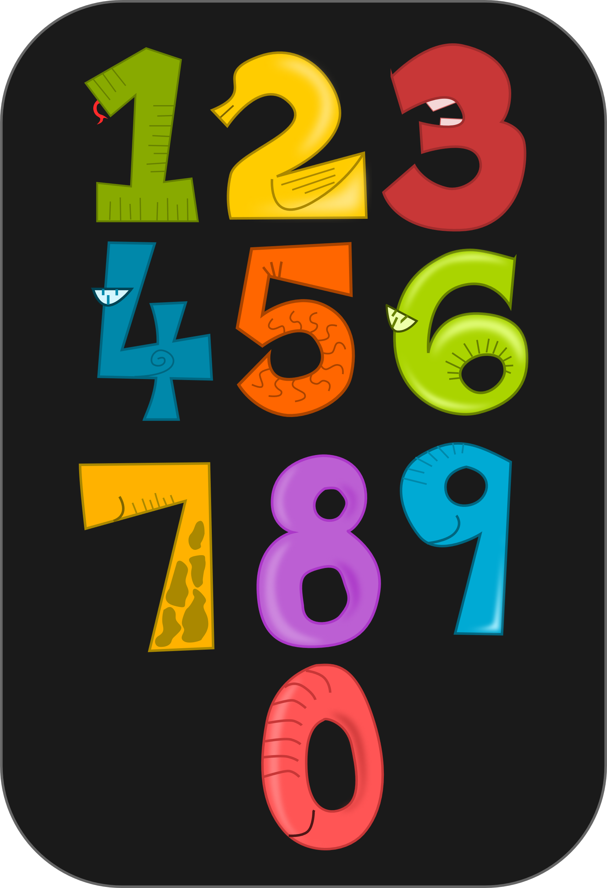  Create Multiplication Flash Cards for …  4s  6s  9s | Art   Draw a new cover for the book that you are reading currently. Include a front and back cover.
Social Studies  Many famous people have been on postage stamps. Choose a famous person you think should be on a stamp, and create it. | Writing   Write a letter of appreciation to someone special in your life. Include at least 3 things you enjoy about them. | Math 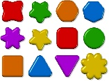  Use shapes to draw pictures of members of your family or group of friends. Use at least 4 varying shapes.
Writing  Based on the last book you read, write a short sequel or a different ending.  Illustrate it! | Art   Create a t-shirt design or movie poster about your favorite book. | Science   Research the size of the human brain or the brain of any other animal.  Draw or build a model of it.

